DESIGN PATTERNS AND PRINCIPLES
Exercise 1: Implementing the Singleton Pattern
Logger.java :
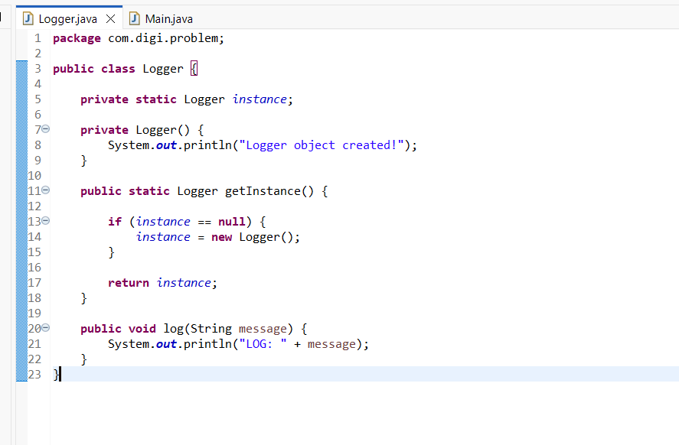
Main.java :
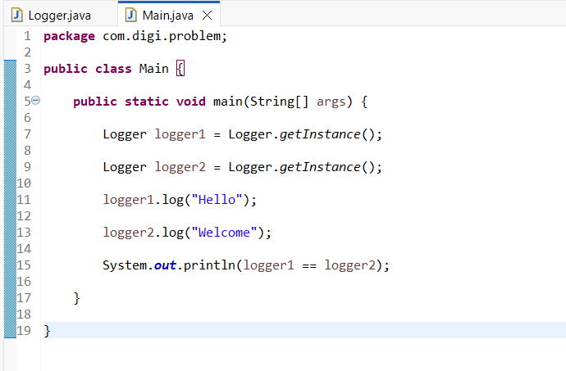
Output:
